**Assignment 4: Artificial neural network report**

Student: Mirza Sijamić

Student ID: msc25001

* Give the structure of your ANN. **(1.25)**

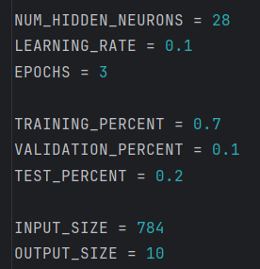

ANN in my solution is constructed of 784 inputs, 10 possible outputs (digits from 0 to 9) and hidden layer of 28 neurons. 784 inputs are there due to the size of images from MNIST dataset which is 28x28 pixels. Training occurs in 3 epochs. Learing rate of each epoch is 0.1.

Training, validation and test percentages just describe how much of data is going to be read from the MINST excel file.

* Give the equations that you used to update the weights explaining all the parameters on them. **(1.5)**

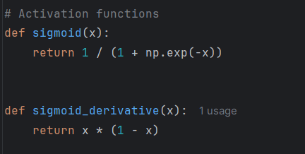

These are the activation functions used in the assignment. I decided to use the sigmoid functon and its derivative.

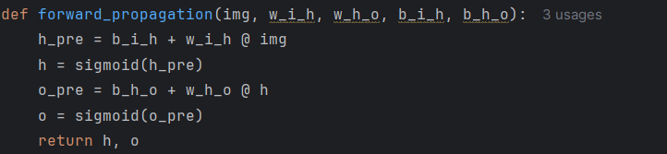

$h_{pre}=b_{ih}+W_{ih}*img$

$h=σ(h_{pre})$

$o_{pre}=b_{ho}+W_{ho}*h$

$0=σ(o_{pre)}$

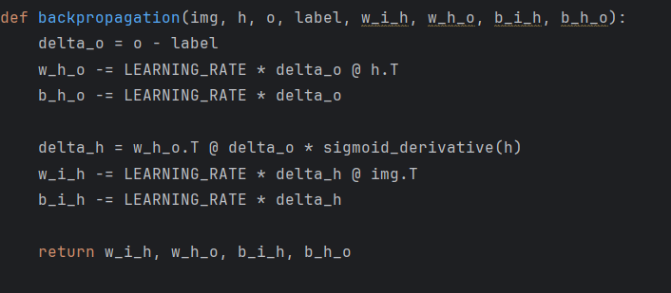

$$δ_{o}=o-label$$

$W_{ho}=W_{ho}-learning_{rate}*δ_{o}*h^{T}$

$$b_{ho}=b_{ho}-learning_{rate}*δ_{o}$$

$$δ_{h}=W_{ho}*δ_{o}*σ^{'}(h)$$

$W_{ih}=W_{ih}-learning_{rate}*δ_{h}*{img}^{T}$

$$b_{ih}=b_{ih}-learning_{rate}*δ_{h}$$

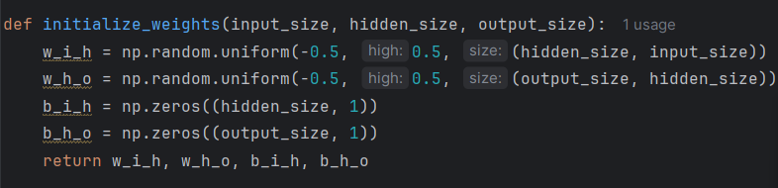

This function creates the initial weight and bias values for the network. It sets up the weights between the input and hidden layer, and between the hidden and output layer, with random values between -0.5 and 0.5. It also initializes the bias terms for both layers to zero, preparing everything for the training process.

* Give the percentage of correctness of the total test data set (20% of all cases) and give the percentage of correctness of each of the classes in the test data set. **(1.25)**

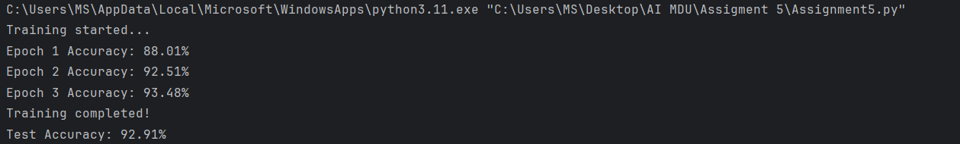

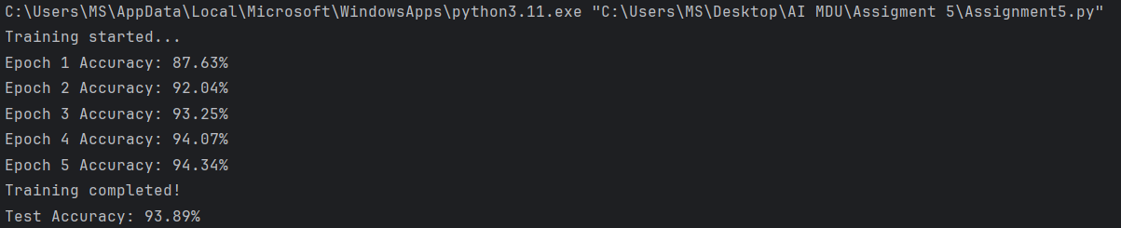

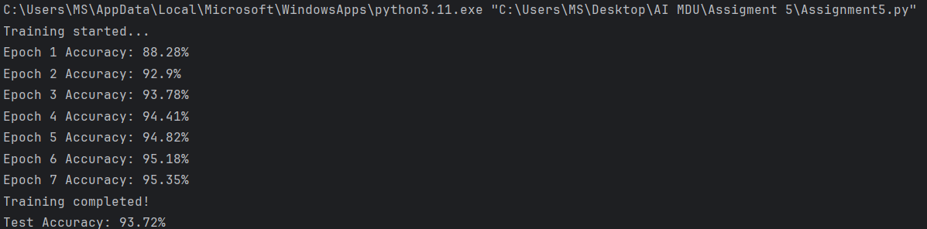

I ran the code 3 separate times, each time I did additional 2 epochs and these were the results. Average Test accuracy across all 3 runs was 93%

* Give a figure showing how the accuracy in the validation set is changing during the training process. **(1.0)**

The graph below shows how the accuracy in the validation set is changing during the training process across 20 different epochs:

